My 8 Habits Goal

Month: _____________________________________

My goal is to work on the habit of: ___________________________________

I chose this habit because _________________________________________
_________________________________________________________________________________________________________________________________

My plan. I will do these things to achieve my goal: _______________________
_______________________________________________________________________________________________________________________________________________________________________________________________________________________
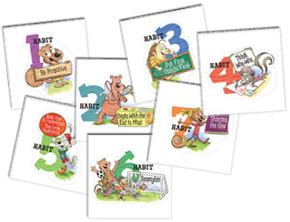
7 Habits:
- Be Proactive
- Begin with the End in Mind
- Put First Things First
- Think Win/Win
- Seek first to understand, then be Understood
- Synergize
- Sharpen the Saw
- Find Your Voice

Student Signature: _____________________
Parent Signature: ______________________
Teacher Signature: _____________________
Date: ___________________________

